**Урок английского языка в Музее Победы для педагогических классов**

**People’s activities during the World War II**

**Рабочий лист**

**Introduction**



Sum up the role of the Soviet Union in WWII based on what you’ve learnt in no more than 3 sentences.

Share and compare your ideas.

**Task 1**



Study the quotes by W. Churchill (Group 1) and F.D. Roosevelt (Group 2) on the walls of the Hall of Historical Verity. Are any of their ideas similar to yours?

Translate the quotes into English.

____________________________________________________________________________________________________________________________________________________________________________________________________________________________________________________________________________________________________________________________________________________

Use the QR-code to compare your translation to the original quotes. To what extent do the texts differ?

**Group 1**



**Group 2**



Make a list of the vocabulary from the original quotes that you lacked in your translations:

________________________________________________________________________________________________________________________________________________________________________________________________________________________________________________________________________________________________________________________________________________________________________________________________________________________

Add the vocabulary you find most useful to the ***Glossary***.

What are the key points that Churchill and Roosevelt make in their speeches on the role of the USSR in WWII?

**Task 2**



Study the Soviet propaganda posters in the Hall of Historical Verity. What are their key messages?

Use the QR-code or the link below to see American and British propaganda posters. Identify the ones addressing ***teachers and volunteers***. What messages do they convey?

<https://drive.google.com/drive/folders/1OzbSCROGyX_MwMQaCG0c8DsbwBo7nM4H?usp=sharing>





Pick one of the posters to compare and contrast with the Soviet poster of your choice. Use the following plan:

• briefly describe both posters;

• say what they have in common;

• say in what way they are different;

• say which one you find more impressive and explain why.

Do the task **in pairs**. Listen to your partner and comment on his/her talk. Mention:

* if you would add any information;
* if you agree with the conclusion; why/why not.

**Task 3**



Enter the *Feat of the army* hall.

Read the inscription on the wall. What was the role of ***teachers*** in winning the war?

Compare your ideas with the following passage. Complete the text by inserting the appropriate words into the gaps.

|  |
| --- |
| **ordinarily / re-examine / keenly / fighting / understanding / hearing** |

Teachers of English in this time of war must _____ their aims and materials in order to do better the things which they have been trying to do all the time. The skills of reading, speaking, writing, and _____ are more important now than they have ever been. The education of our children for life in a democracy and the _____ of the culture of foreign nations are important parts of our program now if we are to win the peace as well as the war. English teachers need to be _____ aware of these aims, especially in these times.

How can we help young people to realize what it is that America is _____ for? This question must dominate the whole of English instruction. Many of the literary selections _____ taught can be pointed to develop a conception of democratic ideals and to stimulate devotion to those ideals.

(from archives.library.illinois.edu/)

Add the most useful vocabulary to your ***Glossary***.

 What other function extremely important in times of war depends on the efforts of teachers?

**Task 4**



Study the exhibition of weapons. Find at least one weapon belonging to each of the categories:

1. developed by Soviet engineers;
2. captured as trophies;
3. obtained through the Lend-Lease programme.

What do you know about the Lend-Lease policy?

**Task 5**



Watch a short video lecture by the History channel to learn more.

<https://drive.google.com/file/d/1BOM5QwlB42EJNmCS5EaMUtZAIfaevZLL/view?usp=sharing>

**For each task 1–6, choose the best answer.**

1. The Lend-Lease Act initially regulated the conditions of weaponry provision between…
2. the USA and the UK.
3. the USA and the USSR.
4. the UK and the USSR.
5. According to the Neutrality Act, Britain…
6. could not receive weapons from the US under any circumstances.
7. could only get weapons from the US by paying cash and organizing transportation.
8. could get weapons from the US on various terms.
9. Why were some Americans against selling weapons to other countries?
10. It could give unlimited power to the president.
11. It would give more power to the president to participate in other countries’ wars.
12. It could ruin the US economy.
13. The Lend-Lease Act was devised as a way to…
14. support war action without risking American citizens’ lives.
15. avoid supporting any side in the war.
16. earn more money for the state budget.
17. As a result of signing the Act,
18. only Great Britain received military support from the US.
19. Great Britain, Russia and China received military support.
20. a large number of countries received US military support.
21. The Neutrality Act…
22. prevented the USA from interfering till the end of the war.
23. was cancelled when the Lend-Lease Act was signed.
24. became irrelevant because of the attack on the USA.

**Task 6**

**Group 1.** Describe the pictures given. Remember to depict the action and location as well as the foreground and the background. You have 2 minutes to prepare.

**Group 2.** Think about the following features and find the pictures connected with them:

1) different types of troops contributing to defeating the enemy; emphasise their importance in winning the war;

2) the hardships of the civilian population during the war;

3) the cruelty of the war;

4) the heroes of the war;

5) the officers in charge;

6) the partisan detachments;

Students of the first group describe the pictures; students of the second group match the pictures to their features and comment on them.

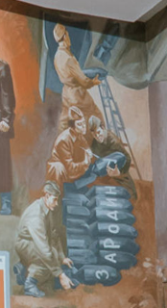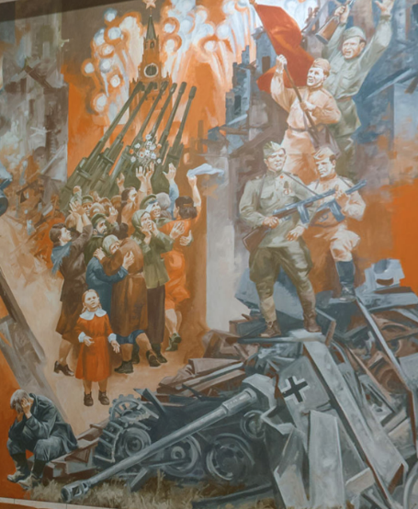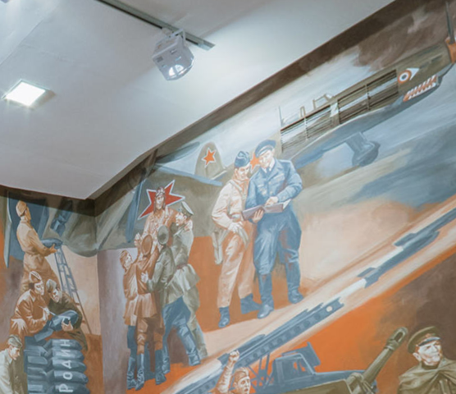

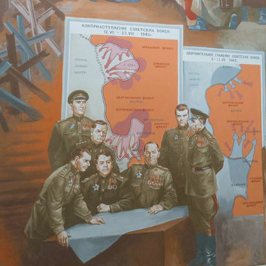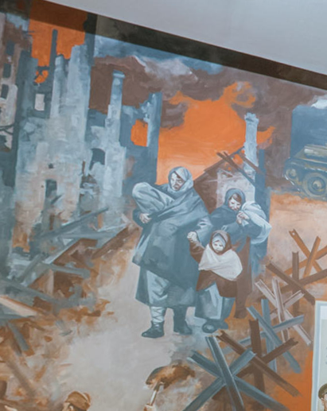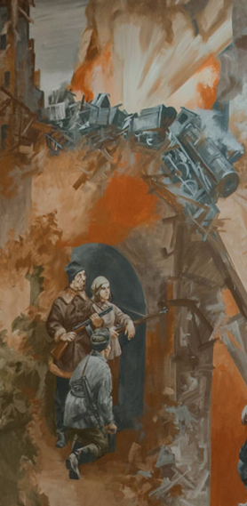

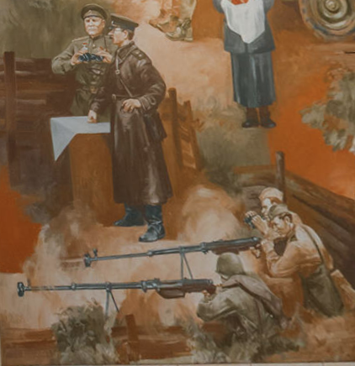

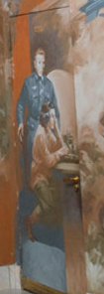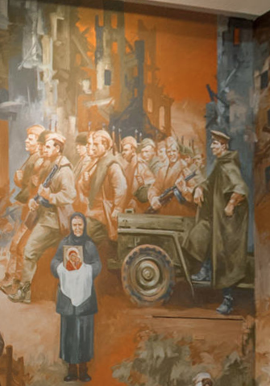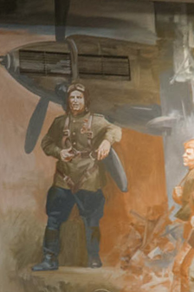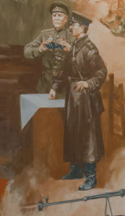

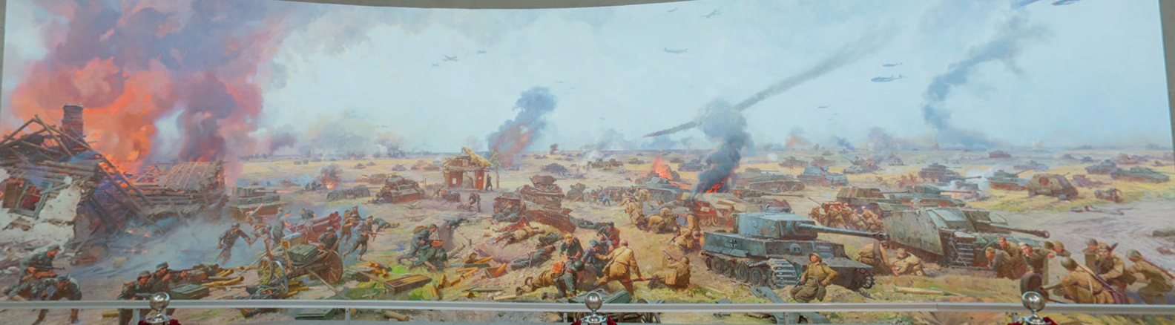

**Task 7**



Return to the Hall of Historical Verity.

Study the infographics titled *Freedom for the West, Salvation for the East*.

The final production task is writing a report based on the data, which you can find in the infographics section on the contribution of **economic and humanitarian support**.

The following plan is to be used:

– make an opening statement on the subject of your report;

– summarise the information by selecting and reporting the main features;

– make comparisons where relevant;

– give an overview of the economic and humanitarian support contribution to the war effort;

– draw a conclusion.

Check out an additional task in the ***Case*** files.