**КЕЙСЫ**

1. **Study the advertisements (in the corridor) and analyse them according to the criteria given below:**

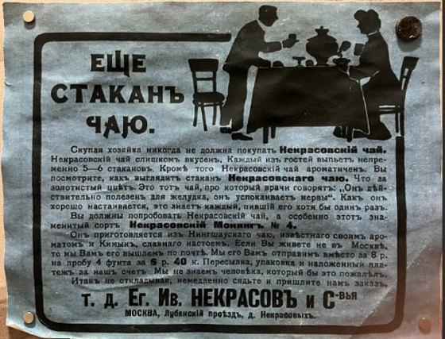 

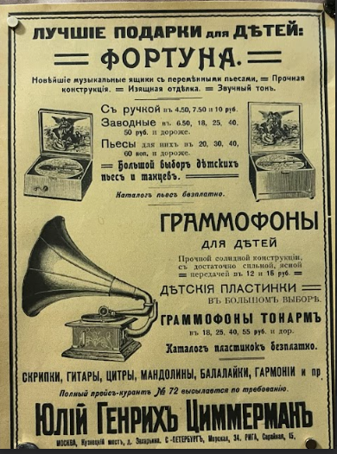 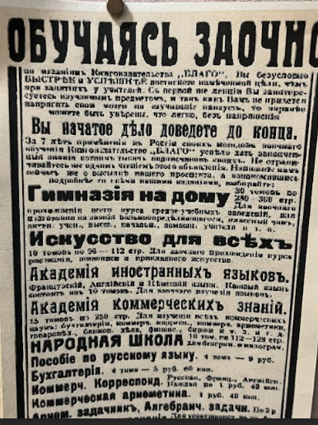

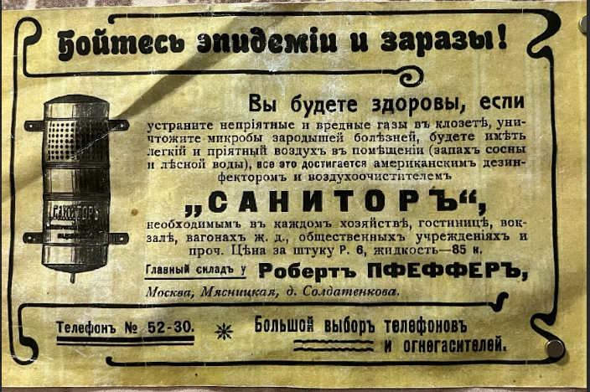 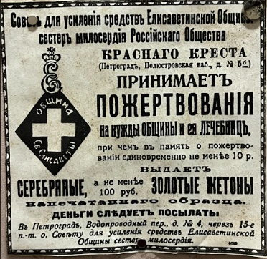

1. Ascertain who the target audience of the advertisement is.
2. Examine how the advertisement tries to get your attention.
3. Determine what sort of mood the advertisement seeks to create.
4. Analyze the language used in the ad.
5. Analyze the images used in the ad.
6. Think about the background and what sort of reaction it’s meant to elicit.
7. Take note of how everything in the ad is spatially situated.

**Design an advertising leaflet for the Museum of entrepreneurs, patrons and benefactors in accordance with the criteria.**

1. **Complete the mind map about the famous entrepreneurs of the 19th century (possible scheme is given below, you may make up your own design). What modern successful entrepreneurs do you know? Make a mind map of a story about them.**

CHARITY

BUSINESS

FIELD

INTERESTING FACTS

LOCATION

FAMILY NAME