Integrated lesson “A School Day in the Archive”
for grades 9–11

Student’s Worksheet
Task 1

An archivist numbers 20 sheets on one side in _____ [insert value from the experiment] seconds. For the same volume of documents, when numbering them page by page (on two sides), it takes him _____ [insert value from the experiment] seconds.
How many hours of working time will be saved by the archivist if he numbers 70 files of 150 sheets each sheet by sheet, that is, on one side, rather than page by page?

Solution

---------------------------------------------------------------------------------------------------------------------------------------------------------------------------------------------------------------------------------------------------------------------------------------------------------------------------------------------------------------------------------------------------------------------------------------------------------------------------------------------------------------------------------------------------------------------------------------------------------------------------------------------------------------------------------------------------------------------------------------------------------------------------------------------------------------------------------------------------------------------------------------------------------------------------------------------------------------------------------------------------------------------------------------------------------------------------------------------------------------------------------------------------------------------------
------------------------------------------------------------------------------------------------------------------------------------------------------------------------------

Task 2

Historical and educational quest based on the exhibition “Nuremberg. Lessons of History”
School, class: _______________________________________________________
Participants: ____________________________________________________________________________________________________________________________________

Assignment 1. Working with a document
Examine the copy of a document. The document was forged: the information in it was replaced with false information. Find the original of this document in the exhibition and write down its name, highlight which three errors you found, and correct them:
Name of the document: ______________________________________________________________
Error No. 1:
______________________________________________________________
Error No. 2:
______________________________________________________________
Error No. 3:
______________________________________________________________

Assignment 2. Crossword
Solve the crossword. In the answers you receive there are cells highlighted in color. Arrange the letters from them in the correct order to get a code word related to the International Military Tribunal in Nuremberg.

Across:
2) In the exhibition of the second hall, “With No Right to Oblivion”, find this medic’s patch. It belonged to one of the prisoners of a German concentration camp. After studying the label for the exhibit, write down the surname of the owner of the patch.

5) In the exhibition of the third hall, examine the caricatures by the creative group of Soviet artists “Kukryniksy”. In one of them, the number “6” in the designation of the year 1946 turns into an object by means of which the punishment was carried out for the main German war criminals. Write down the name of this object.
8) In the second hall, find the electronic photo frame. It presents an information bulletin of the political administration of the 1st Ukrainian Front about one of the German concentration camps. Write down the name of the concentration camp.
9) In the part of the exhibition of the third hall dedicated to the Siege of Leningrad, find the diary of Olga Berggolts. Write down the name of the month dated on the page from the diary displayed in the exhibition.
Down:
1) In the first hall, find the report of the People’s Commissar of Internal Affairs of the USSR S.N. Kruglov and the Prosecutor of the USSR K.P. Gorshenin. Which German general is listed first as a witness to speak at the Nuremberg trial? Write down his surname.
3) In the third hall, find the identification cards of special correspondents issued to V.V. Vishnevsky and Yu.I. Yanovsky to work at the Nuremberg trial. Special correspondents of which newspaper were they? Write down the name of the newspaper.

4) In the exhibition of the first hall, dedicated to the prosecution, there is a photograph of the interrogation of a witness for the Soviet prosecution — former general of the German army E. Buschenhagen. The interaction of which country with Germany in preparing the attack on the USSR did he testify to? Write down its name.
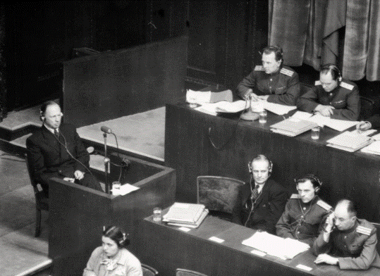
6) In the exhibition of the first hall, “The Court of Nations”, there is a photograph of the Moscow Conference of Ministers of Foreign Affairs of the USSR, the USA, and Great Britain, held in October 1943. Next to the photograph there is a document adopted at the conference. Write down the first word in its title.

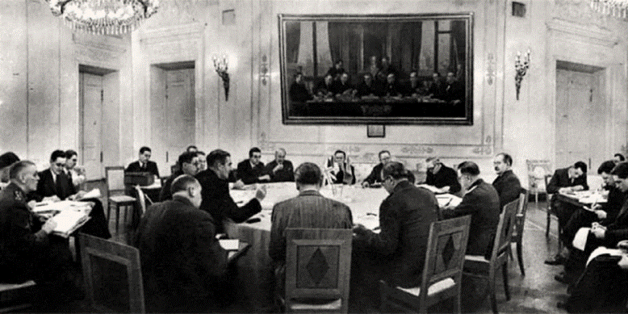
7) In the exhibition of the third hall, “The Nuremberg Trial through the Eyes of Soviet Writers, Journalists, and Artists”, find this notebook. After studying the label on it, write down the surname of the famous Soviet writer to whom it belonged.
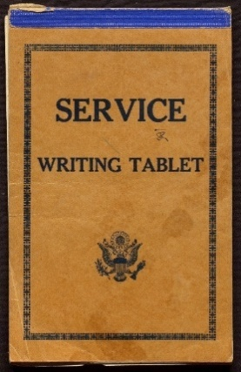
10) In the first hall, a list of interpreters of the Soviet part at the Nuremberg trial is presented. Study it and write down which language was known by the minority of interpreters sent to the trial.
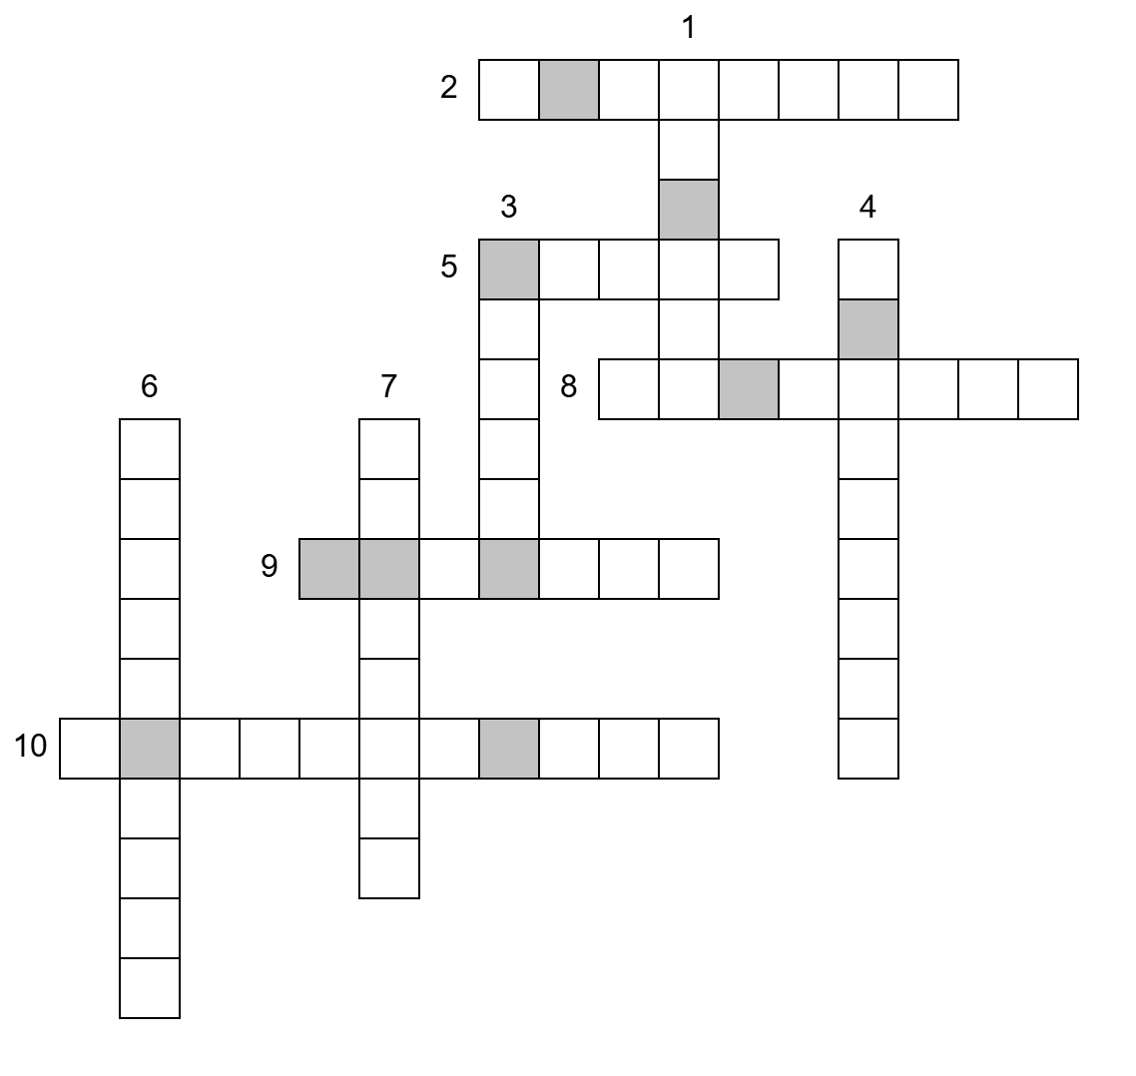

Code word:

